ECE 385

EXPERIMENT #1

Introductory Experiment

I. OBJECTIVE

This experiment is intended primarily to be an introduction to the ECE 385 Laboratory and equipment.

II. INTRODUCTION

A discussion of the theory behind Experiment 1 can be found in the General Guide, parts IV (Design Techniques, GG.22) and VI (Debugging Outside the Lab, GG.29). If you have the opportunity, you should read these sections before coming to lab. If not, you should read these sections after lab. Though the lab portion of Experiment 1 may be completed without reading these sections, understanding of these concepts is critical to both completing the Experiment 1 report and succeeding in the course in general.

III. PRE-LAB

1. Setup the Quartus. Create the project in Quartus, complete the design of the circuit shown in the General Guide, Figure 16 (GG.25) on a Quartus Schematic file. Compile and do the simulation
2. No groups may observe static hazards (why?) If you do not observe a static hazard, chain an odd number of inverters together in place of the single inverter from Figure 16. But no static hazard is find, why? Wait for class and I will tell you.

C. Redesign the circuit of part A to eliminate all static-1 hazards (glitches) at the output. (For a discussion on glitches, see General Guide part IV – “Design Techniques”, “Delays and Glitches” section GG.22-25). Build the circuit in schematic again.

**Demo Points Breakdown:**

The first lab does not have any in-lab demo points. However, results will need to be contained within the lab report.

IV. LAB

1. Test the circuit of part A of the pre-lab by using waveform editor, simulate with **Functional simulation**. Complete a truth table of the output as a function of the three inputs.

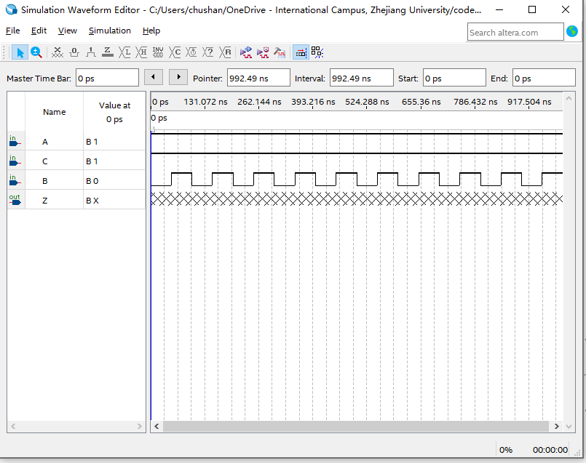

3. Add the Delay modules by adding source codes provided in BB system. Insert the Delay modules follow the schematic shown below.

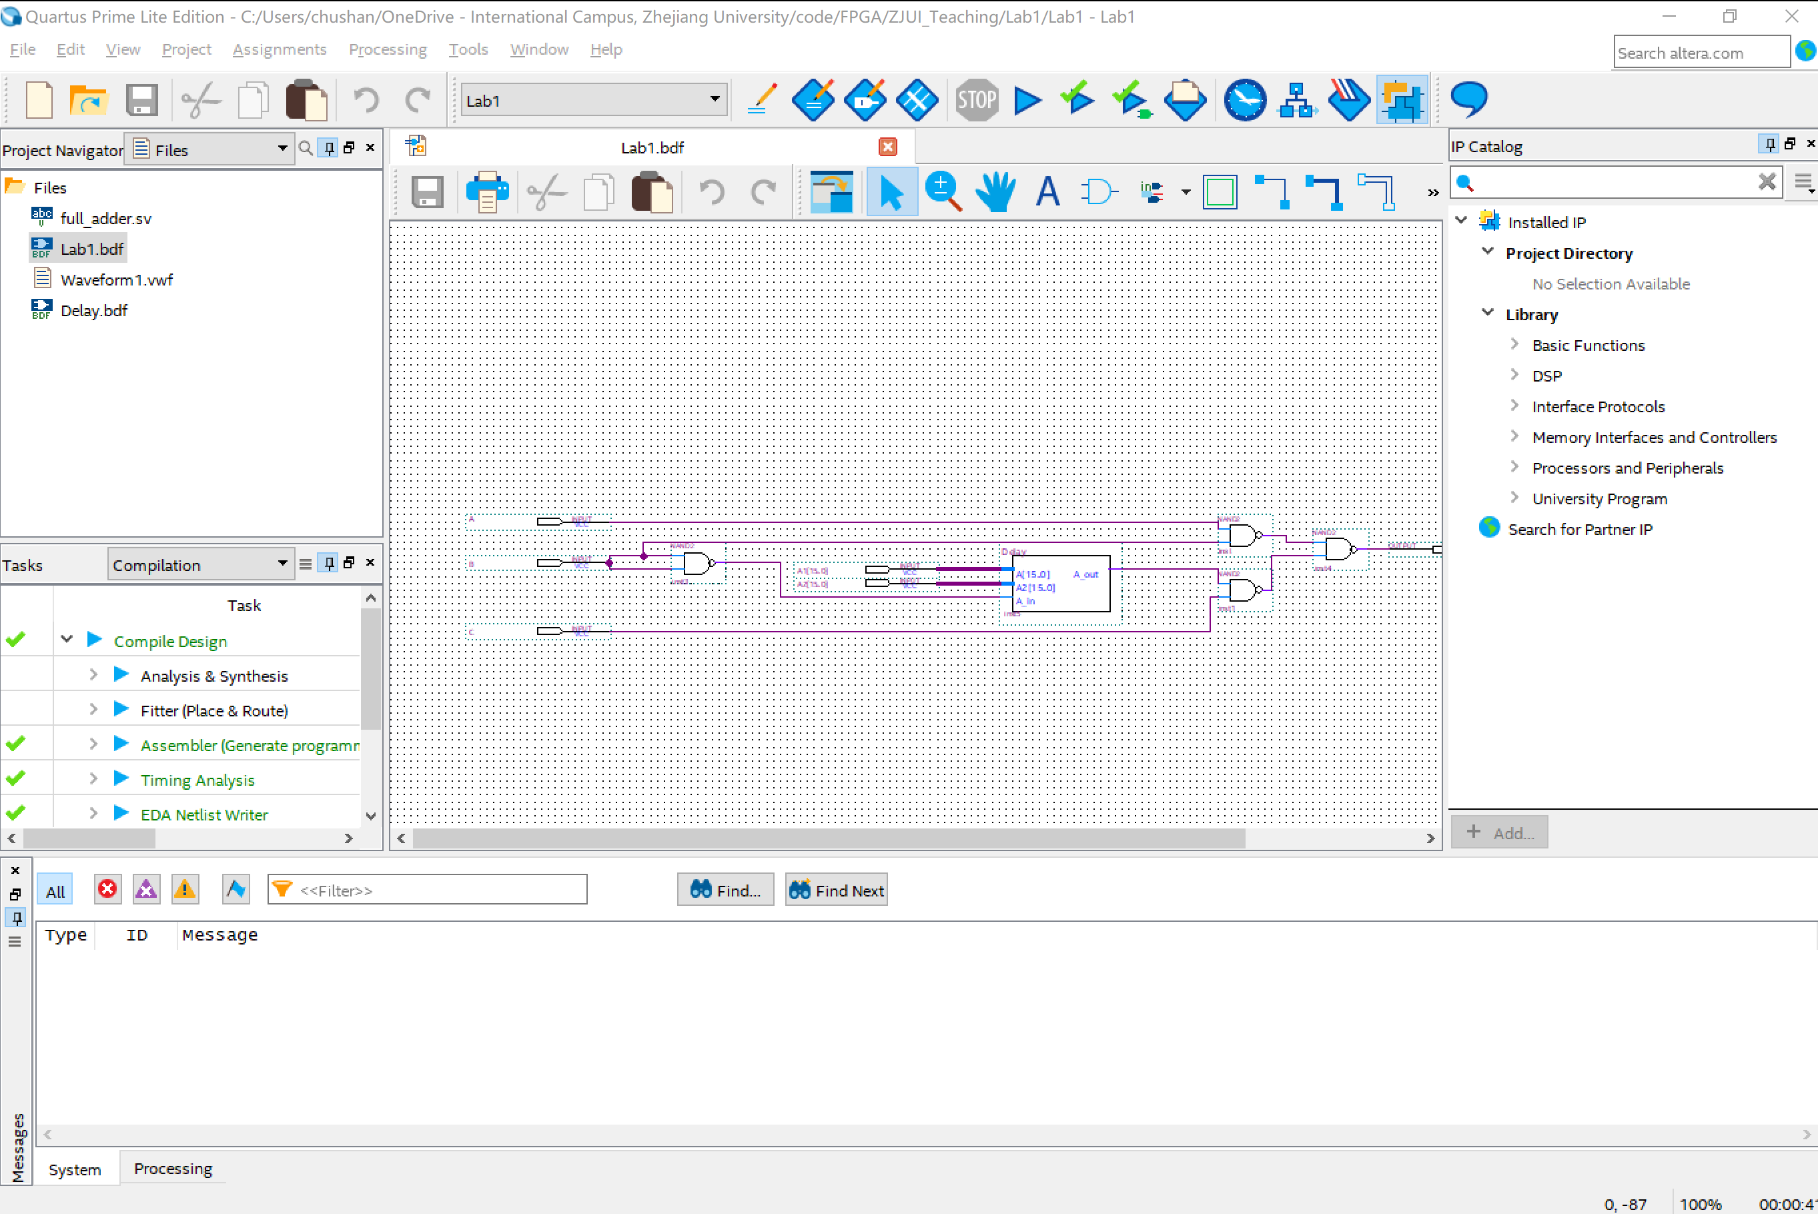

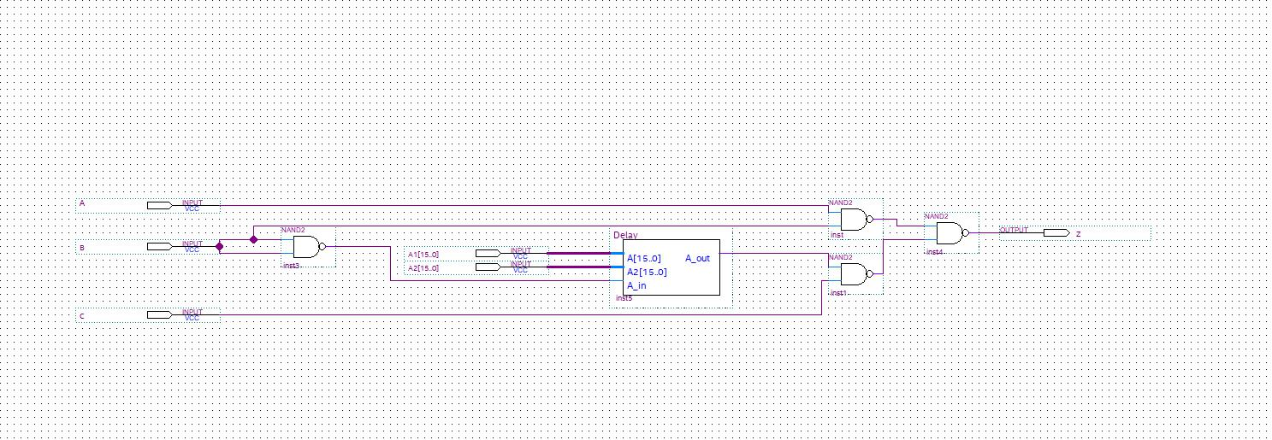

In waveform editor, setting both inputs A and C high, drive input B with a 1 MHz, A1 and A2 Bus to be “1111111111111111” and “0”. Using **Timing Simulation**. Display output Z together with A, B, and C. Pay particular attention to the relation between the two waves and the timing.

**~~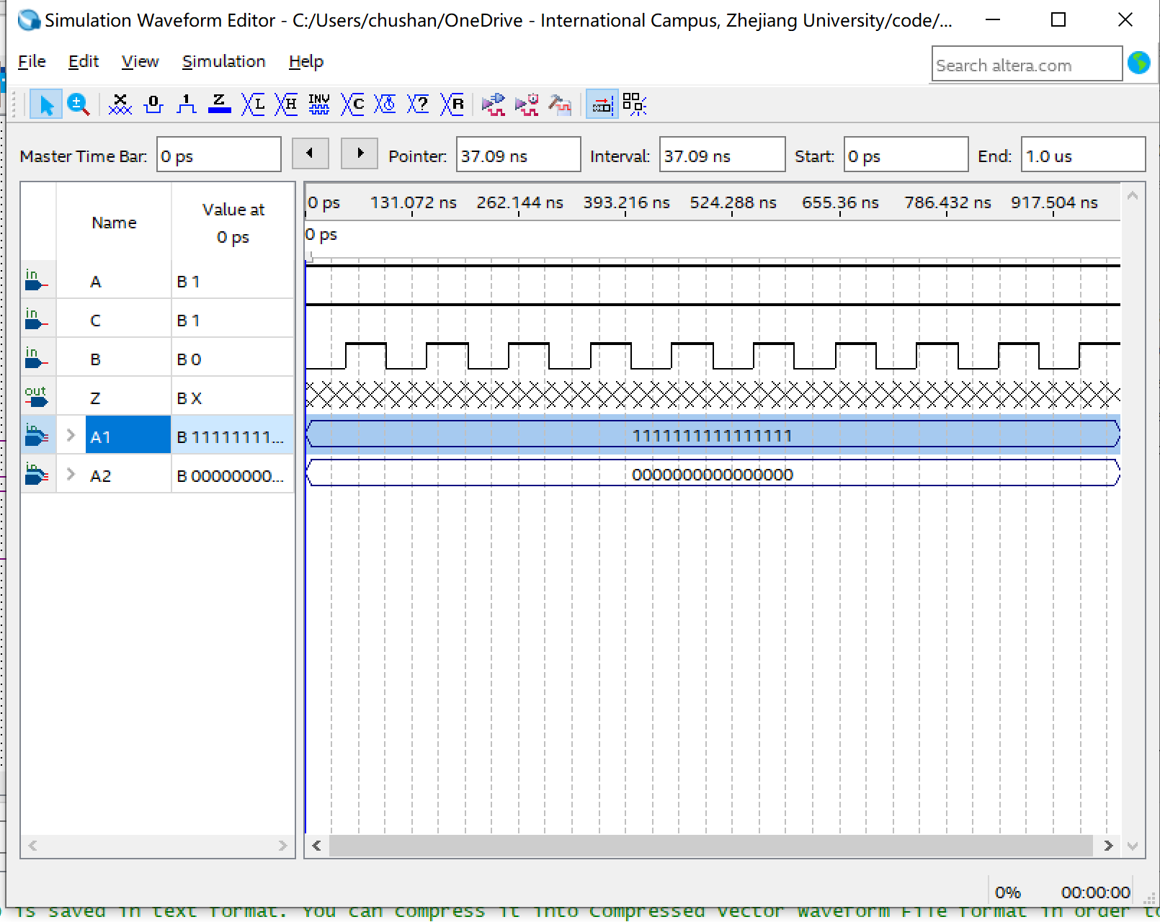~~**

4. Test the circuit in part B of the pre-lab, including Delay module as well. Complete a truth table of the output. Does it respond like the circuit of part A? Describe and save the output and explain any differences between it and the results obtained in part 2. Consider the following question and explain: for the circuit of part A of the pre-lab, at which edge (rising/falling) of the input B are we more likely to observe a glitch at the output?

V. POST-LAB

1.) Given that the guaranteed minimum propagation delay of a 7400 is 0ns and that its guaranteed maximum delay time is 20ns, complete the timing diagram below for the circuit of part A. (See GG.23 if you are not sure how to proceed.)

TIMING DIAGRAM



How long does it take the output Z to stabilize on the falling edge of B (in ns)? How long does it take on the rising edge (in ns)? Are there any potential glitches in the output, Z? If so, explain what makes these glitches occur.

VI. REPORT

For lab report, you should hand in the following: Criterion of the lab report is that, if something is related to the hardware testing, then it is not required this time.

* An introduction;
* Written description of the operation of circuits from both parts of the pre-lab (no need to consider additional delay module);
* Circuit diagrams for all circuits (pre-lab part A and B are two separate circuits);
* Documentation from all parts of the lab. This includes but not limited to a truth table for the circuit of pre-lab part A, answers to the questions posed in the pre-lab, a truth table for the circuit of pre-lab part B
* Simulation Results of part A and part B. The results should clearly show the static hazard problem and the elimination of the problem
* Answers to all post-lab questions;
* Answers to questions from the General Guide (GG.6, GG.29);
* A conclusion regarding what worked and what didn’t, with explanations of any possible causes and the potential remedies.

Note: This lab report is an **individual report**, not a group report. Each person in the lab must hand in his/her own lab report; lab partners can work together but should not hand in copies of the same work. This means that oscilloscope traces may be shared, but answers to the questions should be in each partner’s own words. Combined lab reports will begin at Experiment #2.